Chaotic Double Pendulum
Anish Mokkarala & Nico Carballal


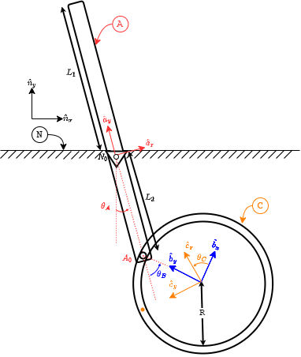
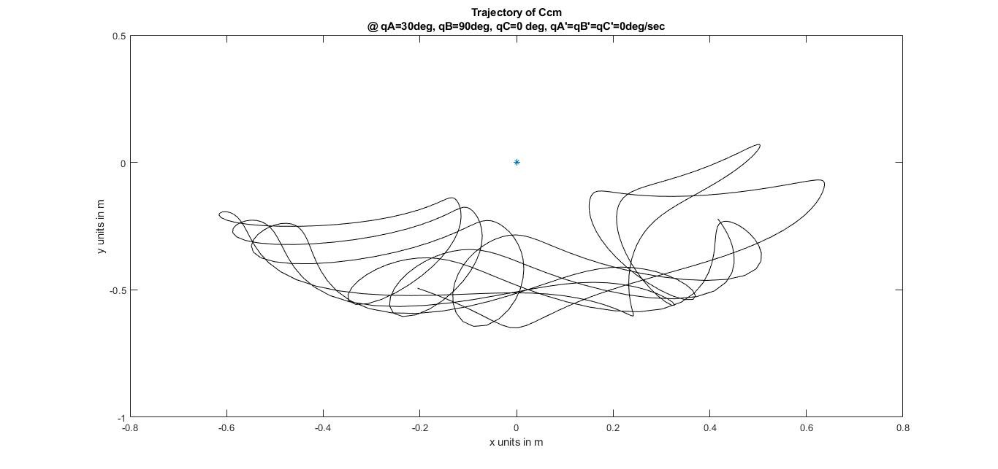

Question:
Given some initial perturbation to a ring connected in a double pendulum set-up as seen below(hyperlinked to YouTube), how can we track the center of mass of the ring?

Model:
Referring to the diagram pictured, the model assumptions are as follows:

- Rigid body A is modeled as a thin rod, and rigid body C is modeled as a thin ring.
- A is connected to a Newtonian Frame N with a frictionless revolute joint at $N_{0 }$. A and C are connected through a frictionless prismatic joint at $A_{0}$, i.e. a pin attached to A at $A_{0}$ can slide freely in a slot along the circumference of C. Also, C can rotate freely about $A_{0}$.
- The mass in A and C is uniformly distributed.
- The rod has a simple rotation about $N_{0 }$, and the ring, has two rotations: one about $A_{0}$ and one about $C_{cm}$.
- Unit vector ${\hat{a}}_{y}$ points from $N_{0}$ to $A_{cm}$. ${\hat{b}}_{y}$ points from $C_{cm}$ to $A_{0},$ and ${\hat{c}}_{y}$ points from $C_{cm}$ to a pre-defined (“painted”) point on the ring C. Also, ${\hat{n}}_{z}$=${\hat{a}}_{z}$=${\hat{b}}_{z}$=${\hat{c}}_{z}$, and are pointing perpendicularly out of the plane of the model.
- There is no aerodynamic drag.

Model Identifiers:

Quantity | Identifier | Type | Value
Earth’s gravitational constant | $g$ | Constant | $9.8 m/s^{2}$
Mass of A | $m_{A}$ | Constant | $2 kg$
Mass of C | $m_{B}$ | Constant | $1 kg$
Length from $N_{0}$ to far end of rod from the ring | $L_{1}$ | Constant | $0.6 m$
Length from $N_{0}$ to $A_{0}$ | $L_{2}$ | Constant | $0.4 m$
Radius of C | $m_{A}$ | Constant | $0.25 m$
Angle from ${\hat{n}}_{y}$ to ${\hat{a}}_{y}$ w/ +${\hat{n}}_{z}$ sense | $θ_{A}$ | Variable | -
Angle from ${\hat{a}}_{y}$ to ${\hat{b}}_{y}$ w/ +${\hat{n}}_{z}$ sense | $θ_{B}$ | Variable | -
Angle from ${\hat{b}}_{y}$ to ${\hat{c}}_{y}$ w/ +${\hat{n}}_{z}$ sense | $θ_{C}$ | Variable | -

Physics:

MG Road-Maps:

Variable | Translate/  Rotate | Direction  (unit vector) | System  S | FBD  Of S | About  point | MG road-map equation
$θ_{A}$ | Rotate | ${\hat{n}}_{z}={\hat{a}}_{z}$ | A, B, C | Below | $N_{0}$ | 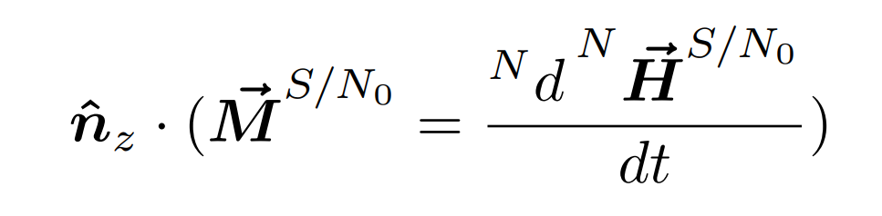
$θ_{B}$ | Rotate | ${\hat{n}}_{z}={\hat{b}}_{z}$ | B, C | Below | $A_{0}$ | 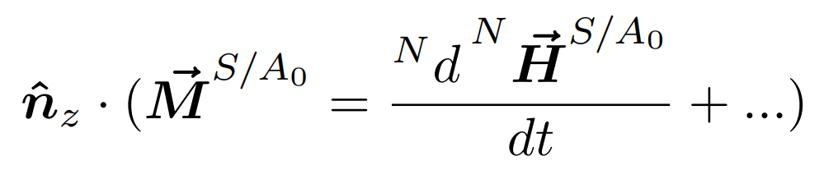
$θ_{C}$ | Rotate | ${\hat{n}}_{z}={\hat{c}}_{z}$ | C | Below | $C_{cm}$ | 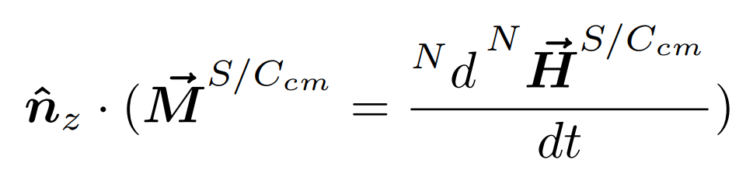

FBDs:

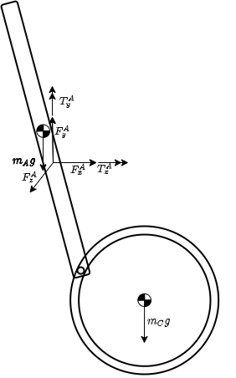  System-A, B, C | 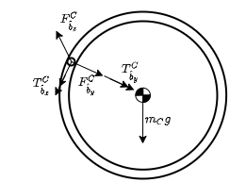  System-B, C
 | System-C

Simplifications/Solve:
No simplifications were made further from the assumptions listed under the Model section. MotionGenesis was utilized to form the ODEs for this system in terms of $θ_{A}'', θ_{B}'', θ_{C }''$ and also to solve them numerically. Both MotionGenesis and MATLAB were used for plotting and GIF generation. The code used in MotionGenesis & MATLAB can be seen in the Appendix section.

Results and Discussion:
The pendulum is given a perturbation such that $θ_{A}$= 30 deg, $θ_{B}$= 90 deg, $θ_{C}$= 0 deg, ${θ'}_{A}$= 0 rad/sec,${ θ'}_{B}$= 0 rad/sec, ${θ'}_{C}$= 0 rad/sec initially. No is shown as a * and the Ccm position is shown as a o in the below GIF (link).

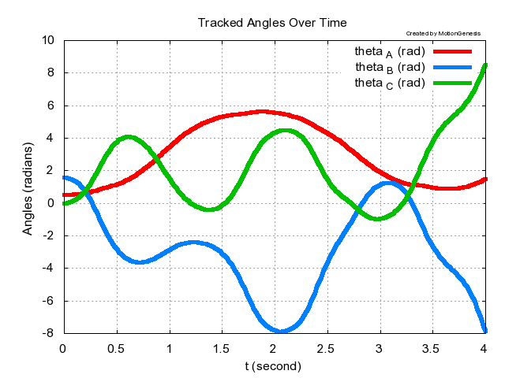 | Tracking our variable model identifiers over time demonstrate the chaotic nature of the system as there is no natural progression for the variables over time. Furthermore, no natural relationship between the variables is intuitively seen from the graph.
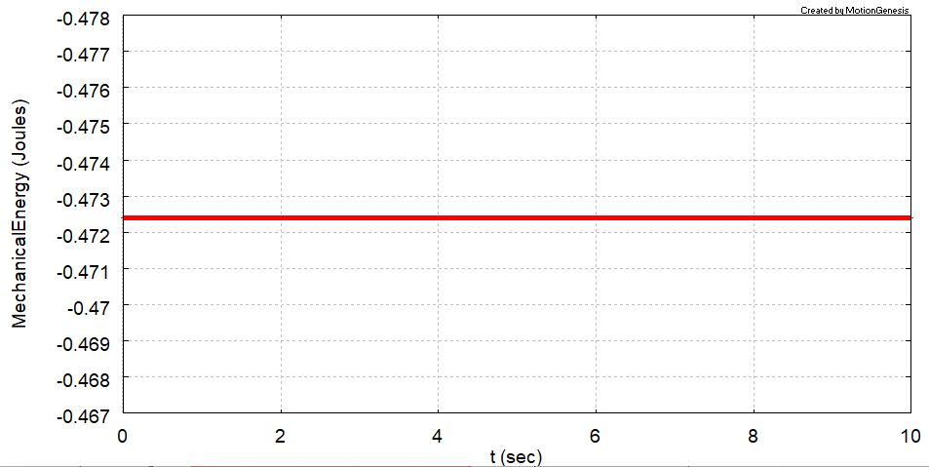 | The Mechanical Energy, $K + U$, of the system stays constant over the entire time. This occurs because only conservative forces (i.e. gravity) act on the system, and no energy is either gained or lost.

Appendix:
MG Code:

NewtonianFrame N
RigidBody A % Rod
RigidBody C % Ring
RigidFrame B % to characterize the rotation of Ccm about the joint at Ao

Variable qA'' % Az> measure of angle from Nx> to Ax>
Variable qB'' % Bz> measure of angle from Ax> to Bx>
Variable qC” % Bz> measure of C's angular velocity in B
Constant L1=0.6 m
Constant L2=0.4 m
Constant r=0.25 m
Constant g=9.8 m/s^2
A.SetMass(mA=2 kg)
C.SetMass(mC=1 kg)
A.SetInertia(Acm, IAxx, IAyy, IAzz=mA*L^2*1/12)
C.SetInertia(Ccm, ICxx, ICyy, ICzz= mC*r^2)

%Specifying rotations
A.RotateZ(N,qA)
B.RotateZ(A,qB)
C.RotateZ(B, qC)

%Specifying points
Acm.Translate(No, (L1-L2)/2*Ay>)
Ao.Translate(Acm, -(L1+L2)/2*Ay>)
Ccm.Translate(Ao, -r*By>)

%Specifying forces
System.AddForceGravity(-g*Ny>)

Dynamics[1]=Dot(Az>,System(A,C).GetDynamics(No))
Dynamics[2]=Dot(Az>,C.GetDynamics(Ao))
Dynamics[3]=Dot(Az>,C.GetDynamics(Ccm))

KineticEnergy = System.GetKineticEnergy()
GravityPotentialEnergy = System.GetForceGravityPotentialEnergy( -g*Ny>, No )
MechanicalEnergy = KineticEnergy + GravityPotentialEnergy
xc=Dot(Nx>,Ccm.GetPosition(No))
yc=Dot(Ny>,Ccm.GetPosition(No))

Input tFinal = 10 sec, tStep = 0.02 sec, absError = 1.0E-08
Input qC = 0 deg, qC’=0 rad/sec, qA=30 deg, qB=90 deg, qA'=0 deg/sec, qB'=0 deg/sec

Solve(Dynamics=0,qA'',qB'',qC”)

Output t sec, qC deg, qA deg, qB deg, xc m, yc m, Mechanical Energy Joules

ODE() MIPSI.m

%Plot MIPSI.1 [1,5]
Quit

After running the MIPSI.m file generated using the above code, the following code was used to generate the GIF on MATLAB.

vars = load( 'MIPSI.1' );
t = vars(:,1);
xc = vars(:,2);
yc = vars(:,3);
h = figure;
filename = 'track_Ccm';

for n = 1:length(xc)
plot(0,0,"Marker","*");
hold on;

for i=1:n
a=1-i/n;
b=1-i/n;
c=1-i/n;
plot(xc(i),yc(i),"Marker","o","Color",[a b c]);
axis([-0.8,0.8,-1,0.5]);
end

hold off;
drawnow

% Capture the plot as an image
frame = getframe(h);
im = frame2im(frame);
[imind,cm] = rgb2ind(im,256);

% Write to the GIF File
if n == 1
imwrite(imind,cm,filename,'gif', 'Loopcount',inf);
else
imwrite(imind,cm,filename,'gif','DelayTime',0.05,'WriteMode','append');
end
end

